**SHOULDER POSTERIOR LABRAL/INSTABILITY REPAIR**

**REHAB PROTOCOL AND POST-OP INSTRUCTIONS**

This protocol may vary in length and aggressiveness depending on factors such as: Size and location of the tear, associated injuries/procedures, strength/pain/swelling/range of motion status, primary vs revision repair, rehabilitation goals and expectations

**For Patients at a glance**

a. **Brace:** Use abduction sling **x 4 weeks post-op** even while sleeping.May remove sling for exercises/therapy and showering.

i. For large instability repairs **you may be instructed to wear the sling for 6 weeks**.

b. **Physical Therapy:** Begin physical therapy within 7-10 days after surgery.

c. **Dressing/Shower:** May **remove bandage post-op day 3** and clean shoulder with alcohol and gauze. Keep any steri-strips/sutures in place and reinforce with band aids as needed. **Ok to shower, keeping shoulder covered and as dry as possible** with saran wrap or something similar and tape while dressing is still on.

d. After removing dressing on 3rd day, you do not need to keep shoulder covered for showers. Do not scrub incisions while in shower. Just let soap/water drain over shoulder and pat dry. Do not submerge incisions in bath or pool until fully healed (3-4 weeks)

e. You may have been given an ice machine to help with swelling/pain control after surgery. Use

20-30 minutes every 1-2 hrs for the first few days and then as needed thereafter. If you do not have an ice machine, use cold packs/ice bags.

f. If you had a **nerve block at the time of surgery, it usually wears off between 1-2 days post- operatively**. It is normal to have some numbness in the shoulder/arm the first few days after surgery as a result.

g. Take the prescribed pain medications as directed. You can supplement your pain control with over-the-counter ibuprofen and Tylenol if needed, making sure to follow the dosage as recommended on the bottle.

h. There is no conclusive data about safe to return to driving after shoulder surgery. You cannot drive while taking pain medications. It is a good idea to arrange for someone else to drive for the first few weeks. Return to driving is highly individualized and is generally guided by your ability to drive safely and your ability to make evasive maneuvers if that was required.

**I.** **REHABILITATION PROTOCOL. PHASE I: INITIAL POST-OP PHASE DAYS 1-7**

a. Abduction sling at all times, even while sleeping

b. Home exercises:

i. **Elbow and Wrist Range of Motion (ROM):** Work on achieving full elbow flexion and extension. Work on wrist flexion/extension/supination and pronation while

keeping shoulder steady and in neutral position.

ii. **Hand Squeezing Exercises:** Work on grip strengthening. Can make a fist and hold or use foam ball.

iii. **Pendulum Exercises:** Come out of the sling. Bend over slightly at the waist while holding on to something (e.g. countertop). Slowly move the arm in small circles. Can do 3x/day

iv. **Supine Assisted Shoulder Flexion:** Lie on back with arm at side and thumb pointed towards ceiling. Use your nonoperative arm and grab the operative side at the wrist slowly raising the operative arm to 90 degrees only

**II.** **REHABILITATION PROTOCOL. PROTECTION PHASE: POST OP WEEKS 1-4**

a. Continue sling. **Start physical therapy at post-op week 2.**

b. Continue previous exercises

c. Full pendulum exercises

d. Can start active assisted range of motion—flexion and abduction

i. **Weeks 1-2: Active assisted flexion and abduction limited 90 degrees.**

ii. **Weeks 2-4: AAROM: Flexion and abduction increases to 120 degrees.**

e. Shoulder shrugs

f. Scapular/Deltoid isometrics

g. Can ride stationary bike with shoulder immobilizer on

h. Lifting restrictions: <10 lbs

**III. REHABILITATION PROTOCOL. EARLY STRENGTH/ENDURANCE PHASE: POST OP WEEKS 4-8**

a. Discontinue sling

b. Advance AAROM until near full motion is obtained

c. **Begin active range of motion at week 6**

i. **Goal full ROM by weeks 8-10**

d. Wall climbs, pulleys, functional reach behind the back

e. Initiate sub-maximal pain free isometrics with arm at side at week 6

f. Deltoid isotonics

g. Advance scapular strengthening

h. Lifting restrictions: <20 lbs

**IV. REHAB PROTOCOL. ADVANCED STRENGTH/ENDURANCE PHASE: POST OP WEEKS 8-12**

a. Continue appropriate previous exercises

b. PROM/mobilization as needed to achieve full ROM

c. Posterior rotator cuff, latissimus dorsi, and scapular muscle strengthening (focus on eccentric training)

d. Theraband exercises beginning at week 8-10

e. Treadmill: progressive running program

**V. REHABILITATION PROTOCOL. MONTHS 3-4**

a. Continue appropriate previous exercises

b. Progress periscapular strengthening

c. Weight training with light resistance (**pull exercises only)**

i. No overhead resistance/pull downs behind back/bench push ups

**VI. REHABILITATION PROTOCOL. MONTHS 4-6**

a. Progressive weight training, including push exercises

b. Transition to home/gym program

c. Resume all activity as appropriate

d. **Return to Sport:** Return to sport is variable and depends on several factors. In general full range of motion, 90% strength of the contralateral side according to manual strength testing and no shoulder pain with aerobic and upper body conditioning. **No contact sports until 6 months.**

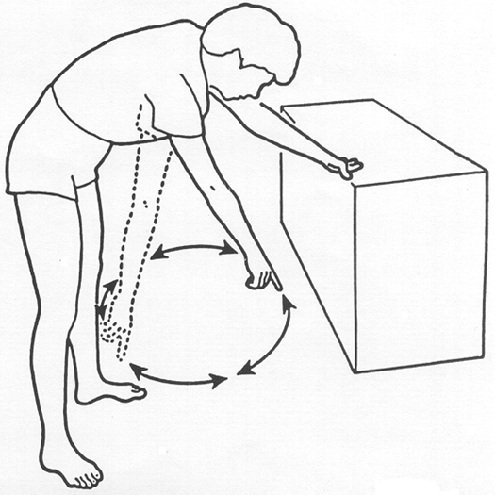

**Pendulum Exercises**

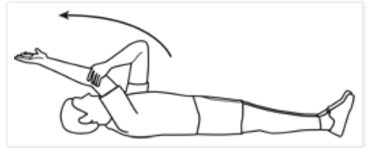

**Supine Assisted Forward Flexion. Do not exceed 90 degrees of flexion until week 2.**